**Assignment 2 – Performing Web Scraping Using Power BI**

1. Website to be scraped: <https://zenodo.org/records/5898311> (Video Game Sales Data)

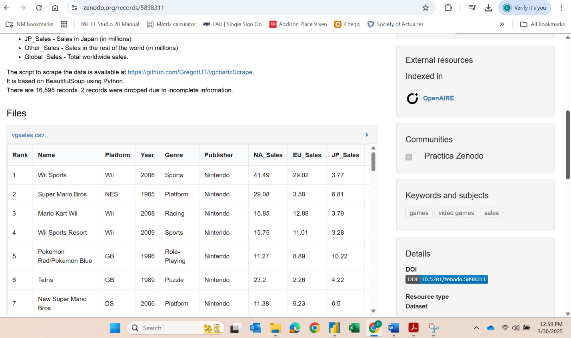

1. Final cleaned up table in Power Query Editor:

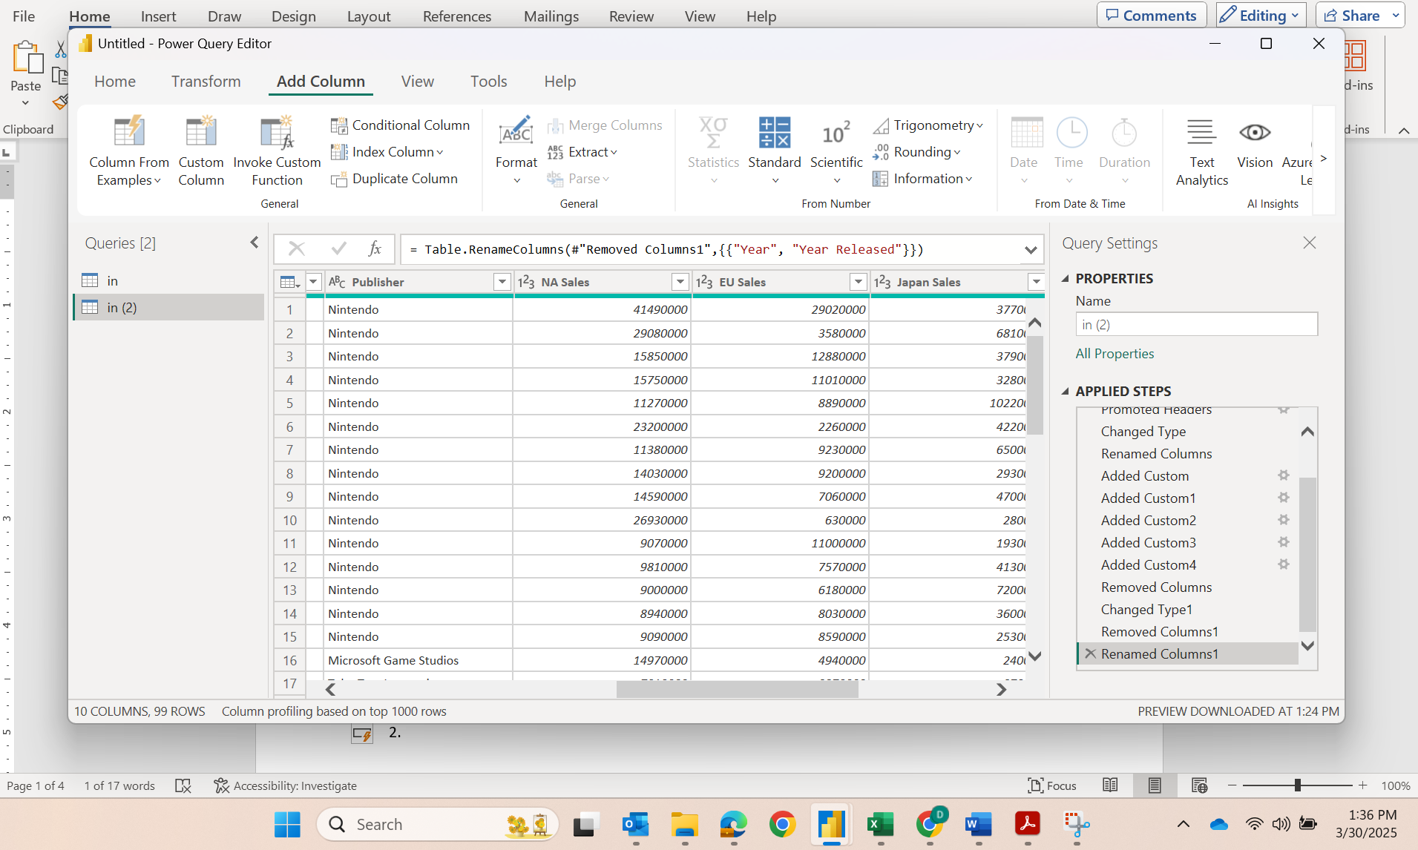

1. Four titled visualizations published on Power BI cloud service.

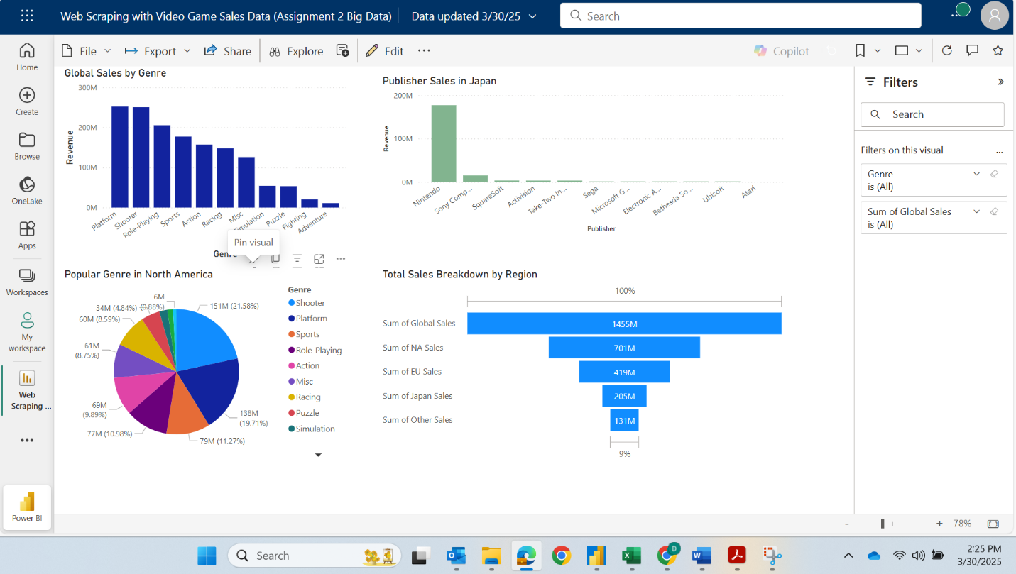

1. Show completed Dashboard showing the 4 visuals:

